**SANJITH R**

**(241059044)**

**linux LAB ASSIGNMENT**

**ME-CYBER SECURITY**

**Network commands**

1. **Ping**

windows

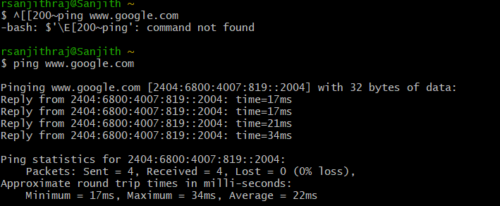

Linox

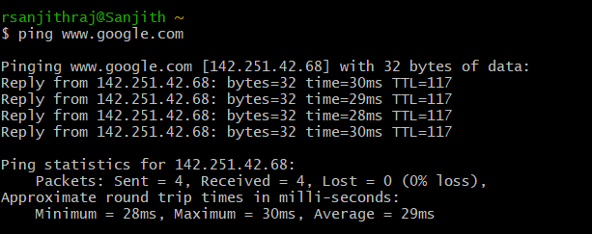

1. **Netstat**

Windows

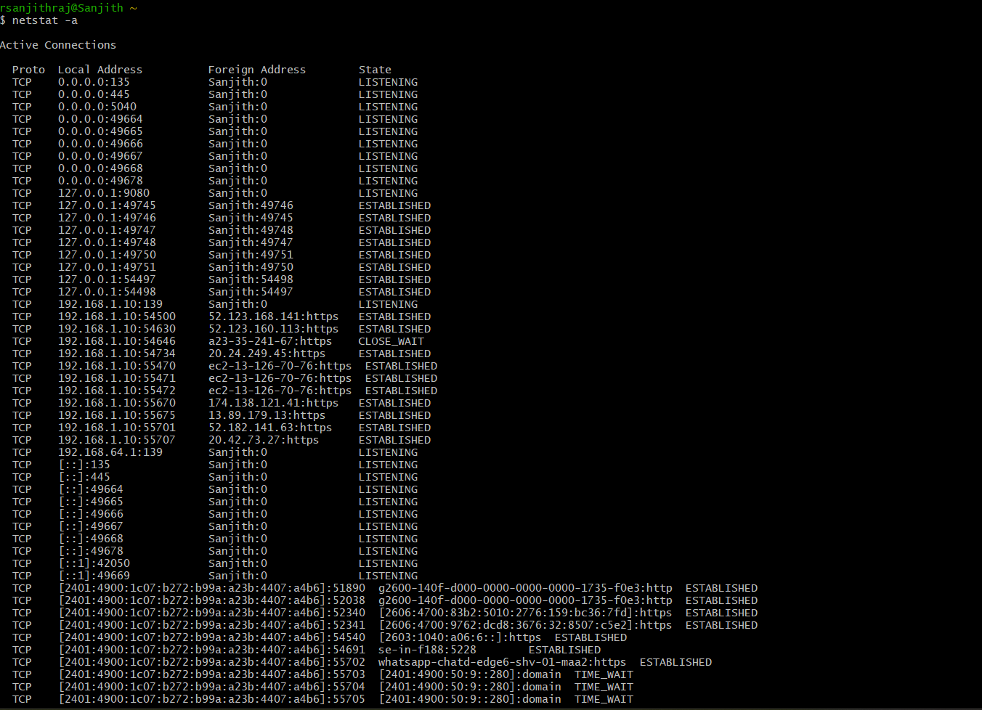

Linox

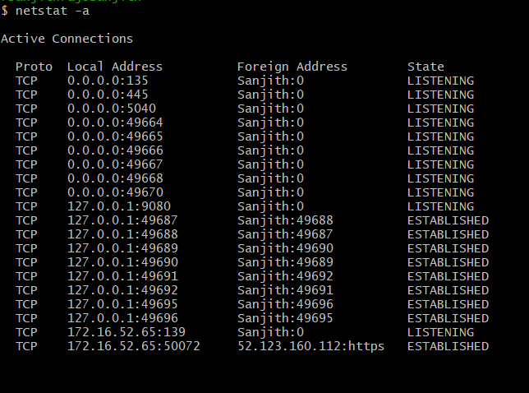

1. **netstat -n # (hosts)**

windows

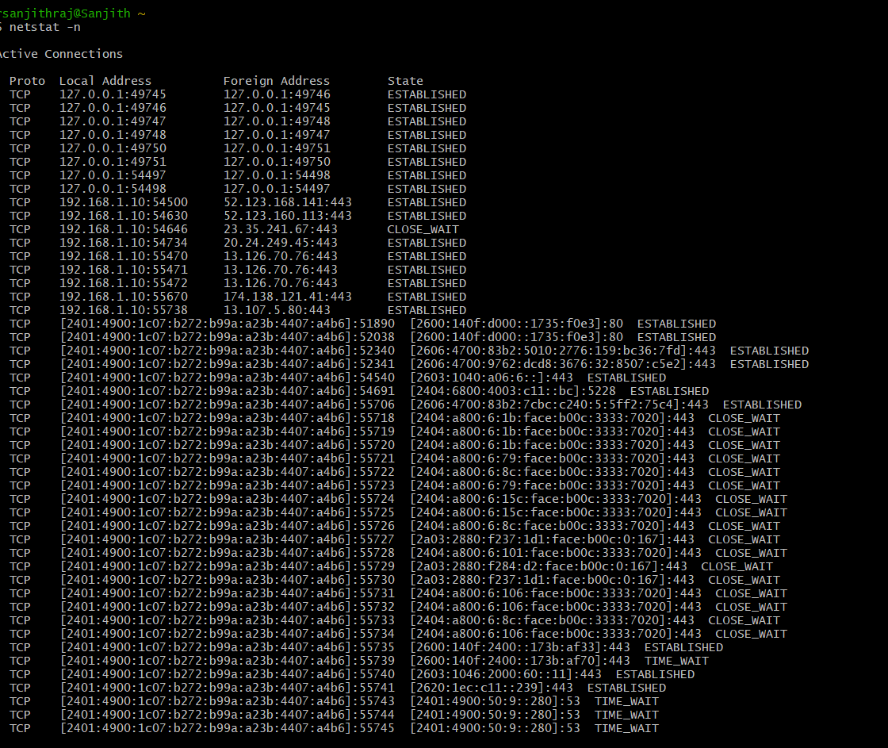

Linox

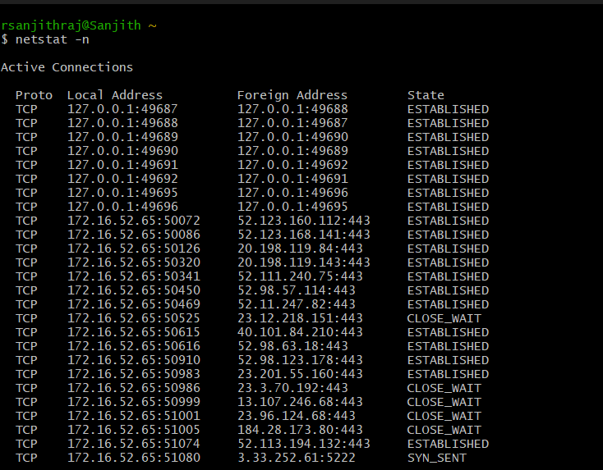

1. **netstat -b # (Show binaries Windows)**

windows

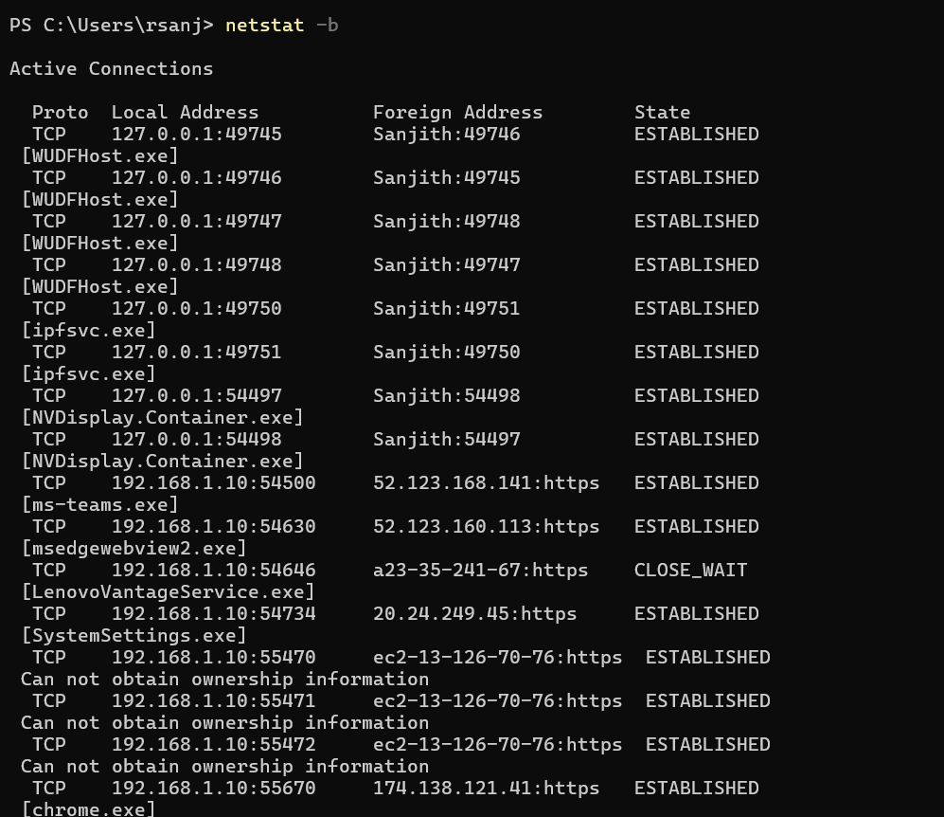

Linox

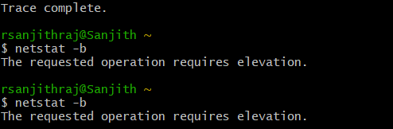

1. **traceroute google.com**

windows

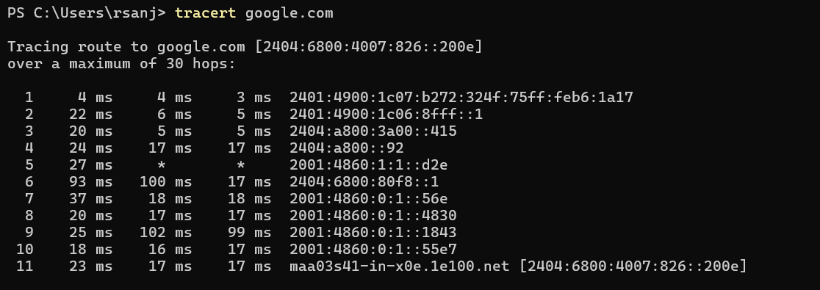

Linox

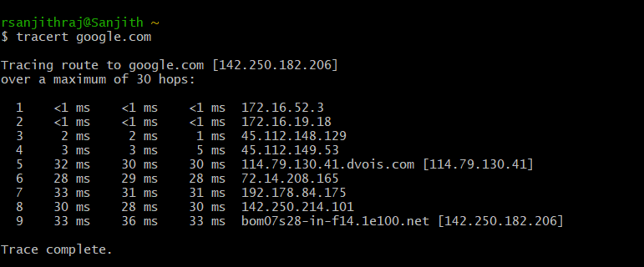

1. **arp**

windows

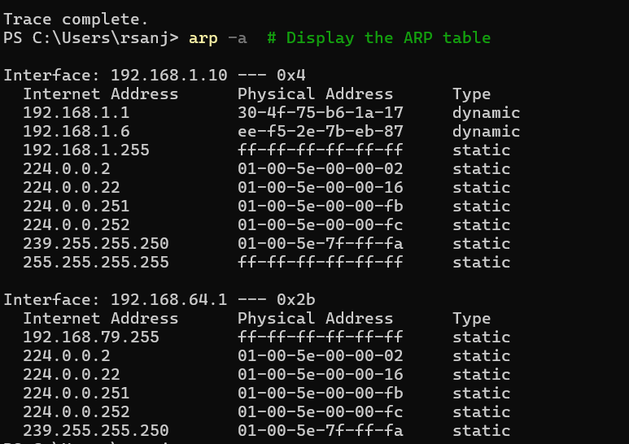

Linox

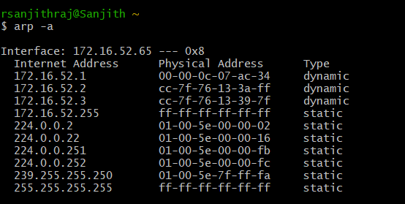

1. **Ifconfig**

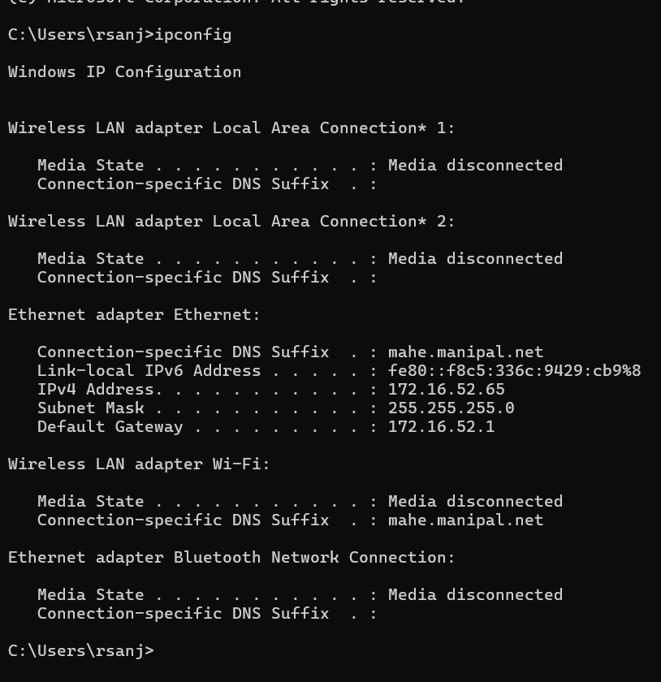linox

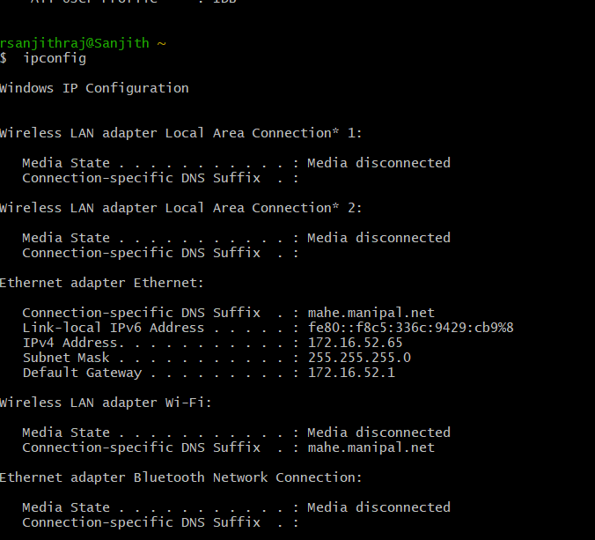

1. **Iwconfig**

WINDOWS

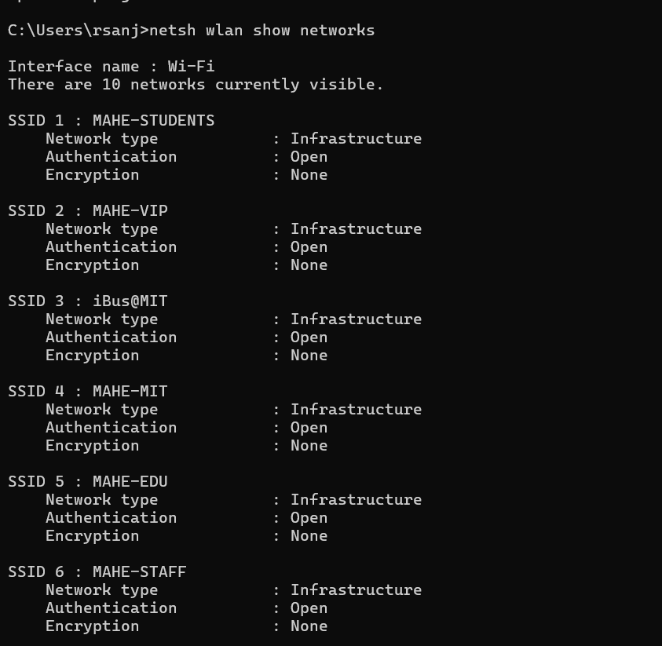

LINOX

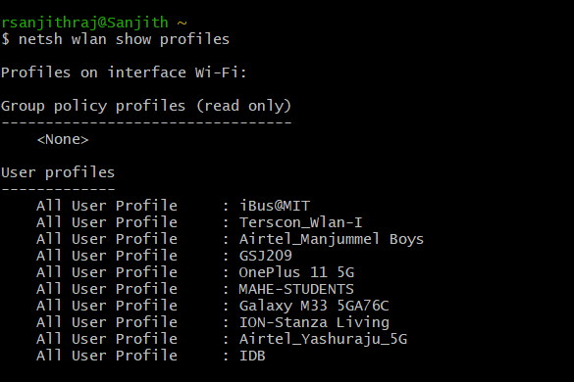

1. **ip addr**

WINDOWS

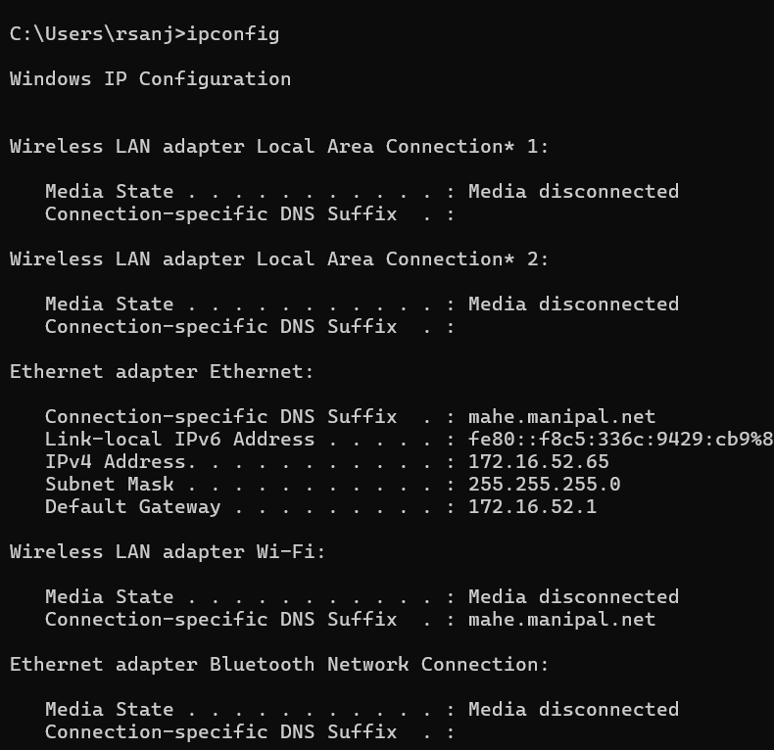

LINOX

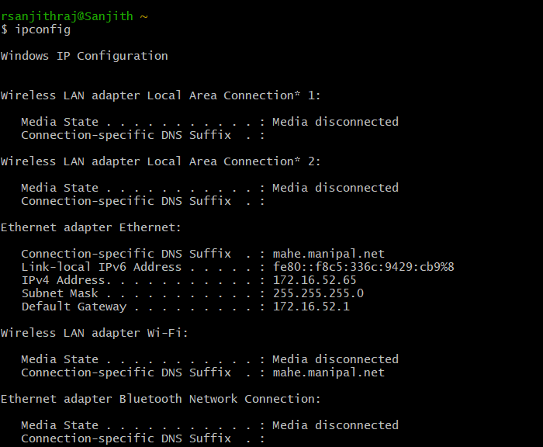

1. **nslookup**

windows

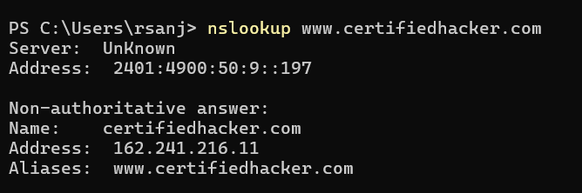

Linox

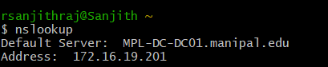

1. **stat**

stat can return the status of an entire file system, the status of the first hard disk and so on.

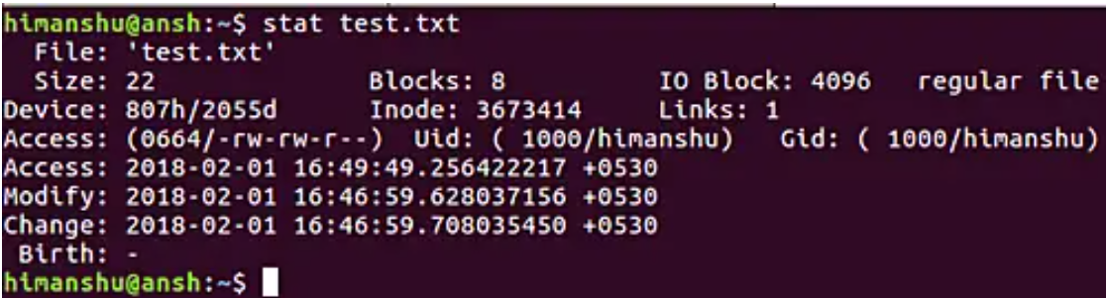

* Archive attribute - **Windows** - if something is created or changed